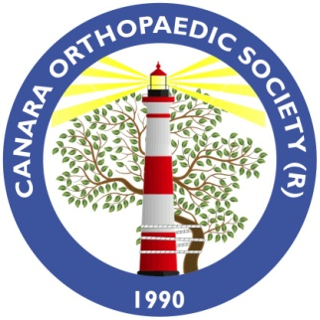
CANARA ORTHOPAEDIC SOCIETY (REGD.)
IMA House, Behind Wenlock Hospital,
Attavar, Mangalore -575001.
Ph: 0824-4251578, 4261314.
email : cosmangalore@gmail.com
Website: www.cosmangalore.org
MANGALORE (REGD.) Society Number:- DKM/S-13/12-13

PLEASE FILL IN BLOCK LETTER ONLY:-

Name : Dr ………………………………………………………………………………………………………………………….
Qualification:-…………………………………………….Speciality;………………………………………………………………………..
Medical Council Reg.No:-…………………………….State:……………………………………………………………………………
Date Of Birth:-…………………………………………..Blood Group:-…………………………………………………………………

Residence Address:-…………...................................................................................................................
…………………………………………………………………………………………………………………………………………………………..

Consulting Address:-…………………………………………………………………………………………………………………………..
…………………………………………………………………………………………………………………………………………………………..
Contact No:-
Consulting:-……………………………Mobile No:-…………………………………….Residence:……………………………….
Fax No:-…………………………………… Email:-……………………………………………………………………………………………
Date……………………………………..Signature Of Applicant:-……………………………………………………………………..
Details :Cash/DD /Cheque/NEFTno/RTGS

